**Website on Microsoft Edge:**

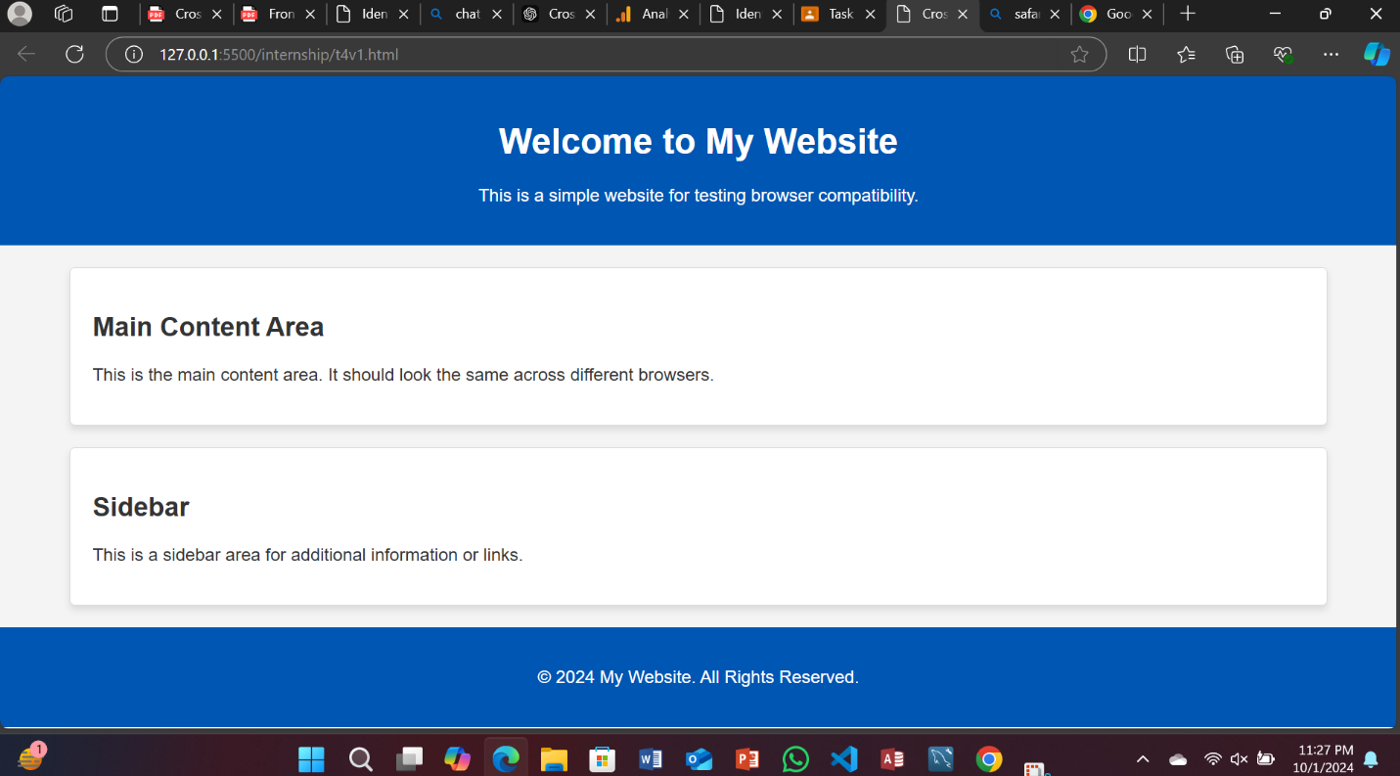

**Website on Chrome:**

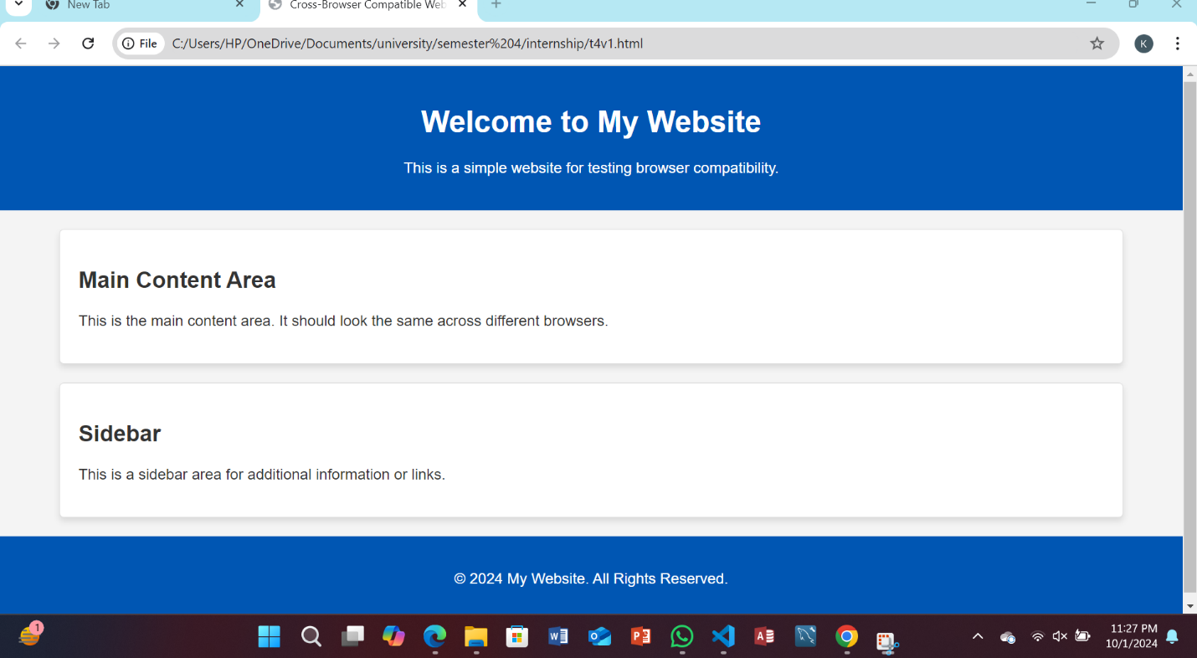

I've successfully completed the process of ensuring cross-browser compatibility for the website by following all the necessary steps:

1. **Identifying Target Browsers and Versions**: I analyzed user data to determine the most relevant browsers for our audience. The website now fully supports the latest versions of Chrome, Firefox, Safari, Edge, and, where necessary, Internet Explorer 11.
2. **Testing Across Browsers**: Using BrowserStack and the built-in browser developer tools (Chrome DevTools, Firefox Developer Tools, etc.), I tested the website across different browser environments. This allowed me to identify discrepancies in layout, functionality, and performance. The **meta tag** <meta http-equiv="X-UA-Compatible" content="IE=edge"> ensures compatibility with **Internet Explorer** in case you need to support older versions.
3. **Debugging and Fixing Compatibility Issues**: I resolved any compatibility issues, including CSS inconsistencies and JavaScript feature support, by adding browser-specific prefixes and employing feature detection. For example, I ensured that styles like box-shadow were rendered correctly across browsers and checked JavaScript support using methods like querySelector.
4. **Implementing Polyfills**: For browsers that lacked support for modern JavaScript features (e.g., fetch() and Promise), I implemented polyfills from sources like Polyfill.io to ensure consistent functionality.
5. **Ongoing Testing and Maintenance**: I've set up a process to regularly test and update the site with the latest browser releases, ensuring it remains compatible as new browser versions are introduced.

In summary, the website has been thoroughly tested and is now fully compatible with all target browsers. Compatibility issues have been addressed, and a future-proofing strategy is in place to ensure ongoing support for new browser versions.